A30 RNDIS Setup

V0.3

Date: 26/02/2021

Linkly Private LTD.

Contents

Change History 3

Introduction 4

Requirements 5

The terminal should support Ethernet Connection type. 5

Terminal RNDIS Support 5

Install PAX RNDIS driver 6

Paydroid Tool: 6

Setup 7

Upgrade OS 7

Enable RNDIS 7

Network Settings 8

Enable RNDIS Programmatically 10

PAX Store web proxy setup 12

Blockers 15

## Change History

|  |  |  |  |
| --- | --- | --- | --- |
| **Version Number** | **Change** | **Author** | **Date** |
| 0.1 | Document Creation | Mayur Wadhwani | 21st December 2020 |
| 0.2 | Enable RNDIS Programmatically | Mayur Wadhwani | 15th January 2021 |
| 0.3 | Proxy Listener Setup | Mayur Wadhwani | 26th February 2021 |

Introduction:

This document deals with Remote Network Driver Interface Specification (RNDIS) solution for PAX terminals which have the capability to support Ethernet connection types.

The document will entail how to check if the terminal already has RNDIS Enabled, how to set up the Network Adapter for the driver & what work needs to be done.

Requirements:

The following lists down each requirement and what needs to be done to support RNDIS. Password for Settings menu is **PAX9876@@.**

You will also need a USB Cable to connect the terminal to the Windows 10.

### The terminal should support Ethernet Connection type.

To check, go to the settings of the terminal. If there is an option for ‘Ethernet Settings’ under ‘Network & Internet’.

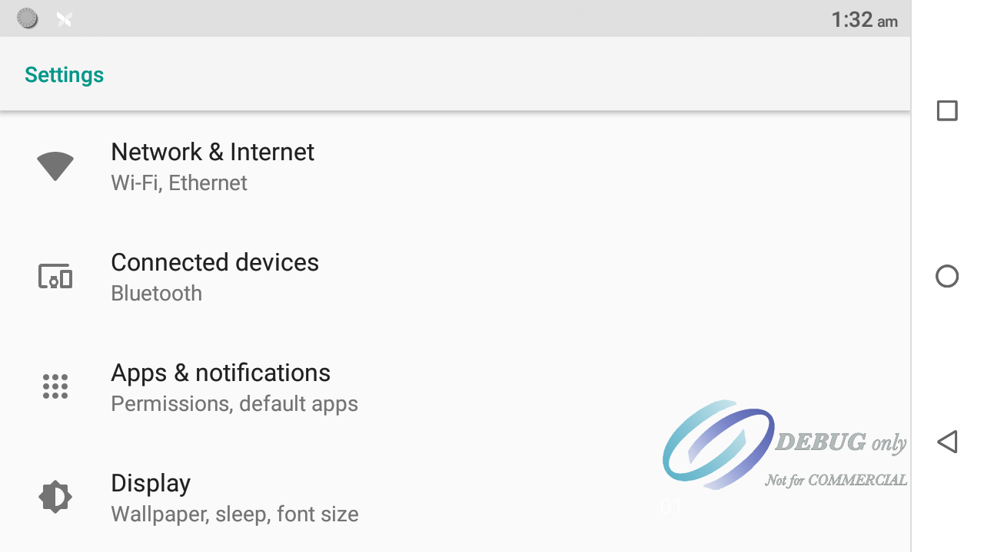

Figure Settings

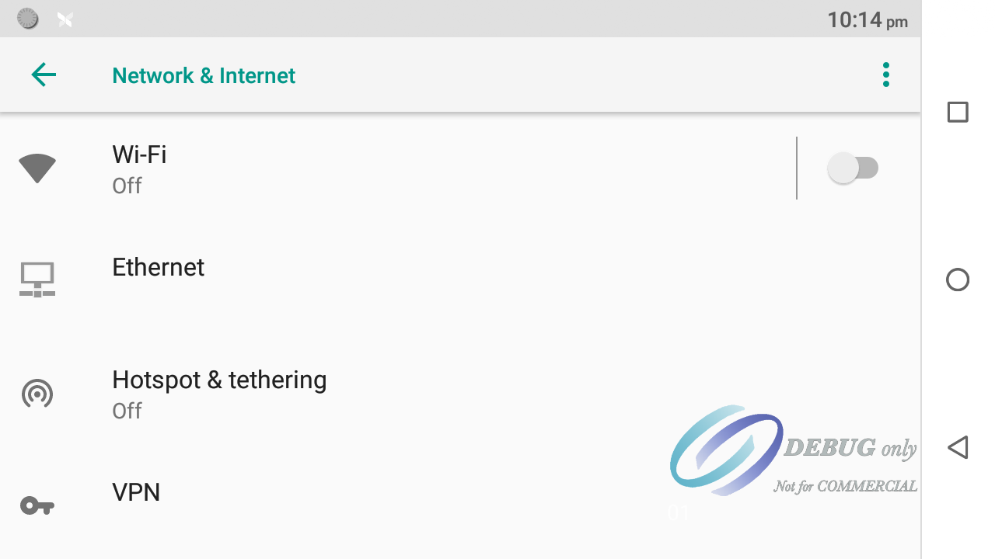

Figure Network & Internet

If user can see **Ethernet** option in the menu then proceed.

Terminal RNDIS Support:

To check if the terminal already supports RNDIS, continue onwards from Network & Internet menu from Figure 2.

* Go to Hotspot & Tethering menu
* If you see the toggle option of **USB-PC Internet Share** option, then your terminal already supports RNDIS. However, you may need to upgrade your OS. Check the Upgrade OS section.

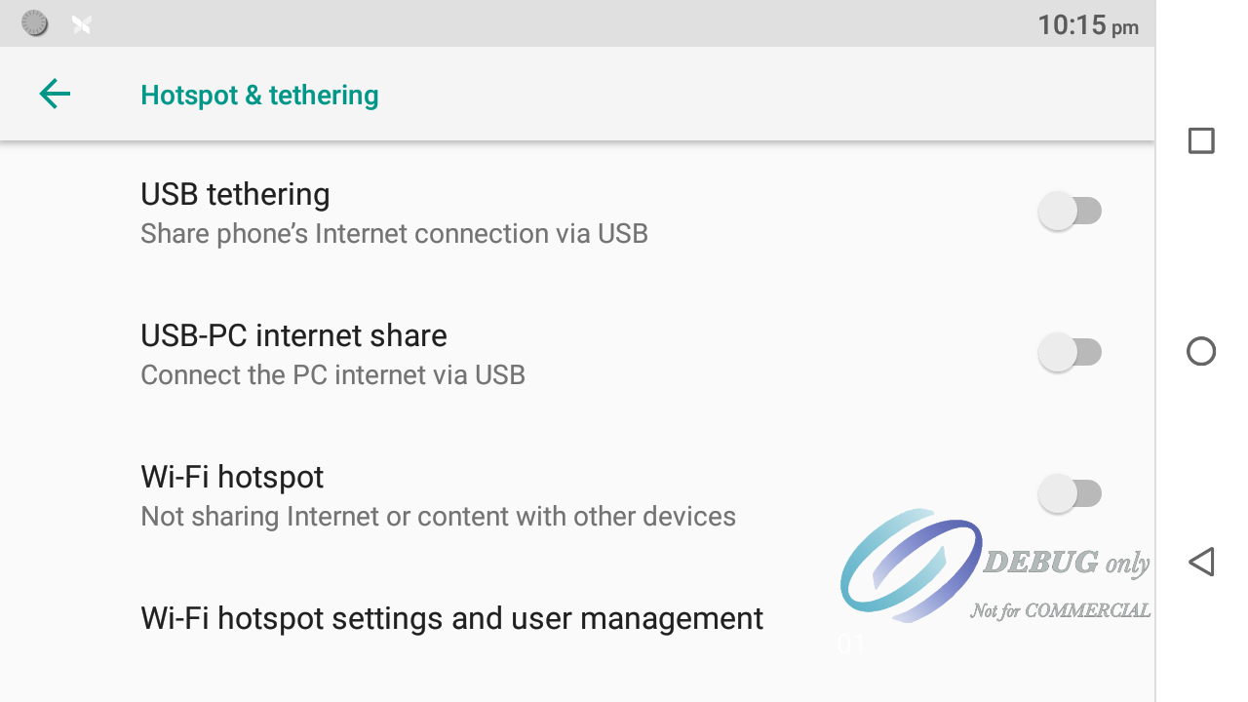

Figure Hotspot & Tethering Menu

### Install PAX RNDIS driver

If Terminal already supports RNDIS, you can toggle it and check your Network Adapters to see if an RNDIS device is visible. If not, you will have to install the PAX RNDIS driver.

Ex: adapter on my Windows 10:

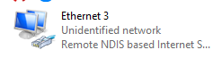

Figure RNDIS Adapter on Windows 10

1. PAX has supplied its own RNDIS Driver, available [here](https://pceftpos.sharepoint.com/:f:/s/IAAS/El-uO-Tn9XNAnxxccO0bnvYBQxF8HSiEEN5cjIyt7y2ZJA?e=VbLQX3).
2. Install using USBDriver.exe

### Paydroid Tool:

This is only a requirement if the OS needs to be upgraded. Document is written with Paydroid tool v1.07.

You can get the Paydroid tool from [Sharepoint](https://pceftpos.sharepoint.com/:f:/s/IAAS/EugfOdFyw1lDoDjnGbllzW4BZ2jY79ootUUza-ht9BtijQ?e=yTbPEF).

Setup:

This section talks about setup of the PAX Device as well as the machine.

Upgrade OS:

If the terminal’s Hotspot & Tethering Menu in Figure 3 does not have an **USB-PC Internet Share** toggle button, then you need to upgrade the terminal OS.

At the time of the writing, the OS which PAX supplied for PAX A30 is **PayDroid_8.1.0_Sagittarius_V11.9.99T9_20200813.paydroid’**.

Download it from [Sharepoint](https://pceftpos.sharepoint.com/:u:/s/IAAS/EWbLbt7-4MBArqGKTatVMAkBBKL3CbgVkEfrDzpiDvDtRg?e=tk3bYo). If you have need access to the OS binary, send us the Email address of the people who are requesting access.

Put the terminal into Firmware installation mode:

* Turn the terminal off.
* Press Power button + Volume up button for a few seconds until you see PAX Logo with text **Firmware download Mode.**

#### Install OS:

* Use the Paydroid tool & select the OS file which is to be downloaded.
* Click download. It will install the OS.

Note: OS Installation usually wipes the whole terminal.

Enable RNDIS:

1. Follow the steps to get to Figure 3 from ‘Check RNDIS Support’. Turn on USB-PC Internet Share.

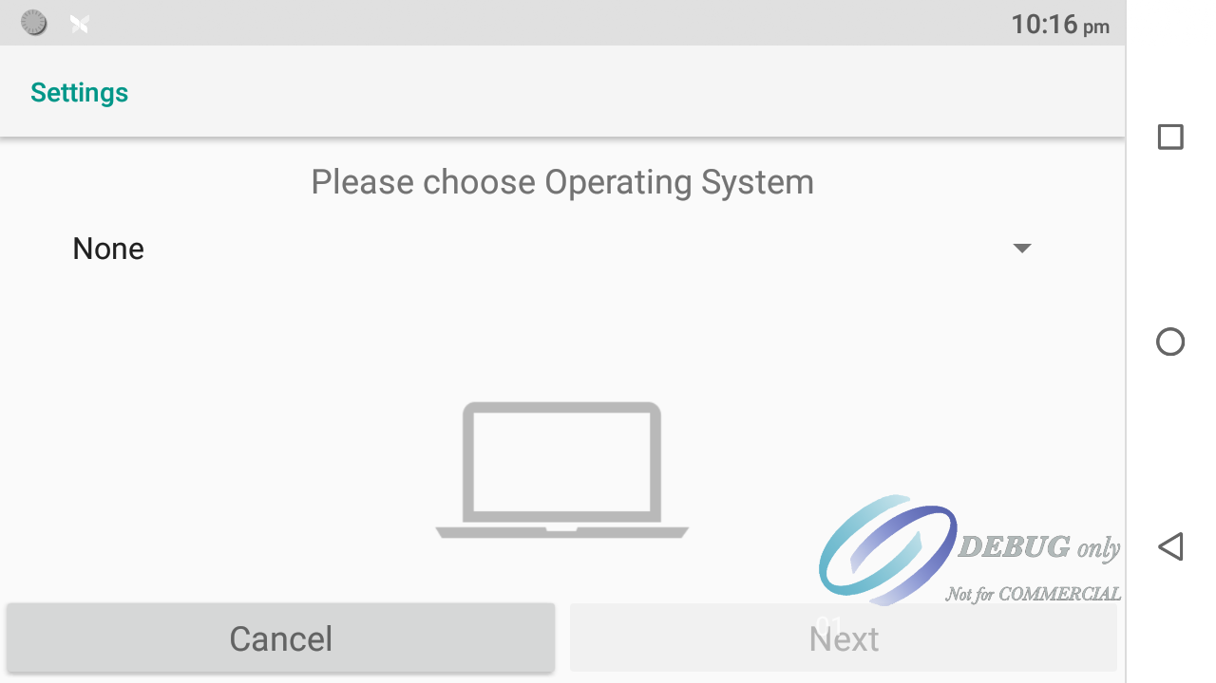

Figure RNDIS-Screen #1

1. The terminal is connected to Windows 10 operating system by USB cable. So select Windows 10.

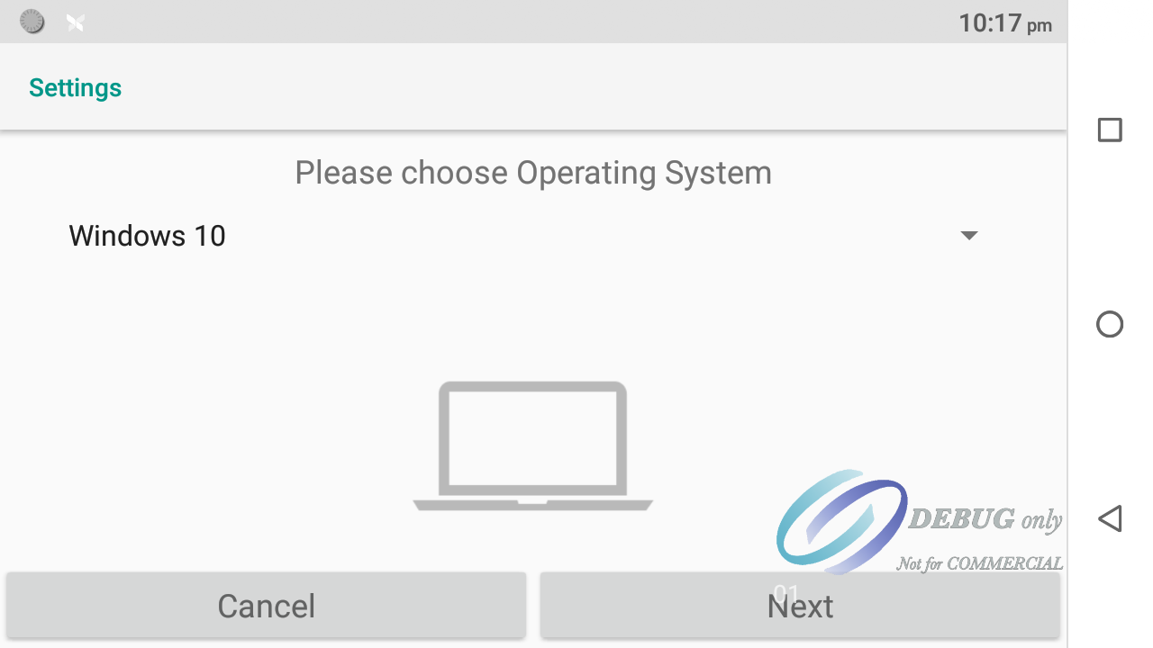

Figure Windows 10 Selection

1. Select **Next**, read the instructions on the page and click **OK**.

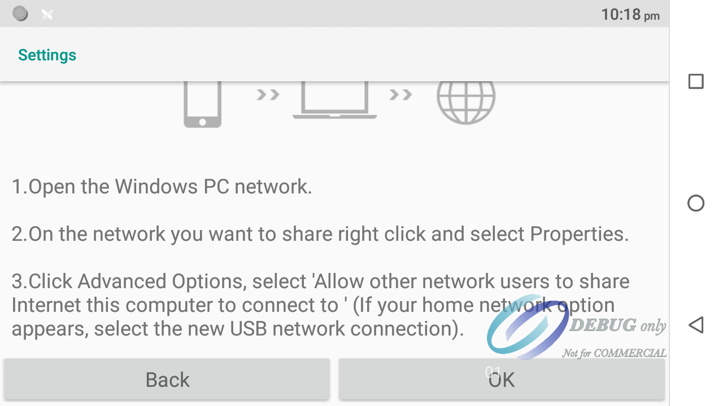

Figure Instructions Page

1. You should see a new adapter in your Windows Network Adapters page from Figure 4.

Network Settings:

The terminal does not allow the IP Address of the terminal to be changed & will always be 192.168.137.129.

The Figure 8 shows IP Address as 0.0.0.0 as RNDIS is disabled.

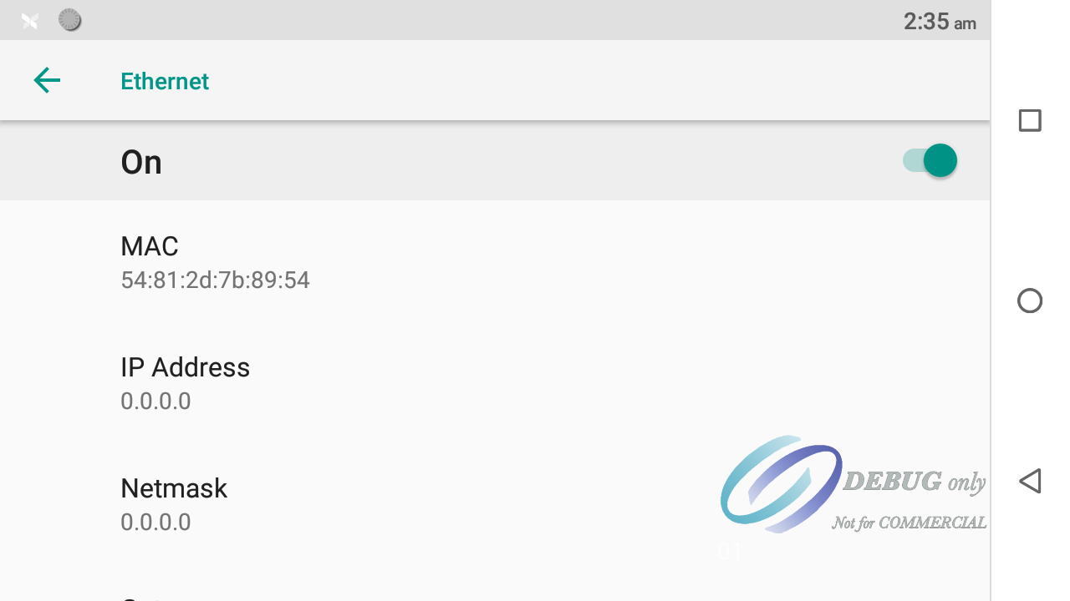

Figure Ethernet Settings

#### Network Adapter Properties

1. Navigate to Network Adapters as mentioned in Figure 4. Open properties of the adapter.

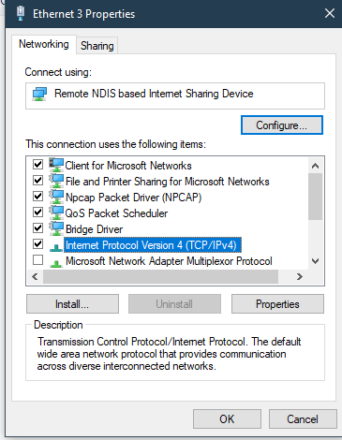

Figure Adapter Properties

1. Open IPv4 Properties & set the following settings.

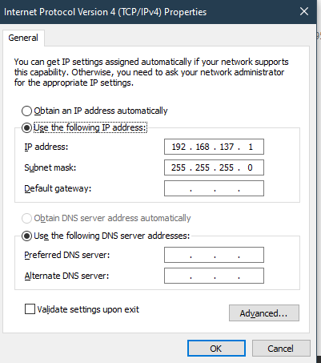

Figure IP4 Properties

1. Replace 192.168.137.1 with the IP Address that should be used. Click OK.

### Enable RNDIS Programmatically

1. Checkout Payment App Branch Feature/IAAS-665-RNDIS-Settings.
2. Build & Install the Payment app onto the terminal.
3. Enter credentials. The payment app may ask to update the password before you can proceed.
4. Enter the App Settings via the Hamburger menu

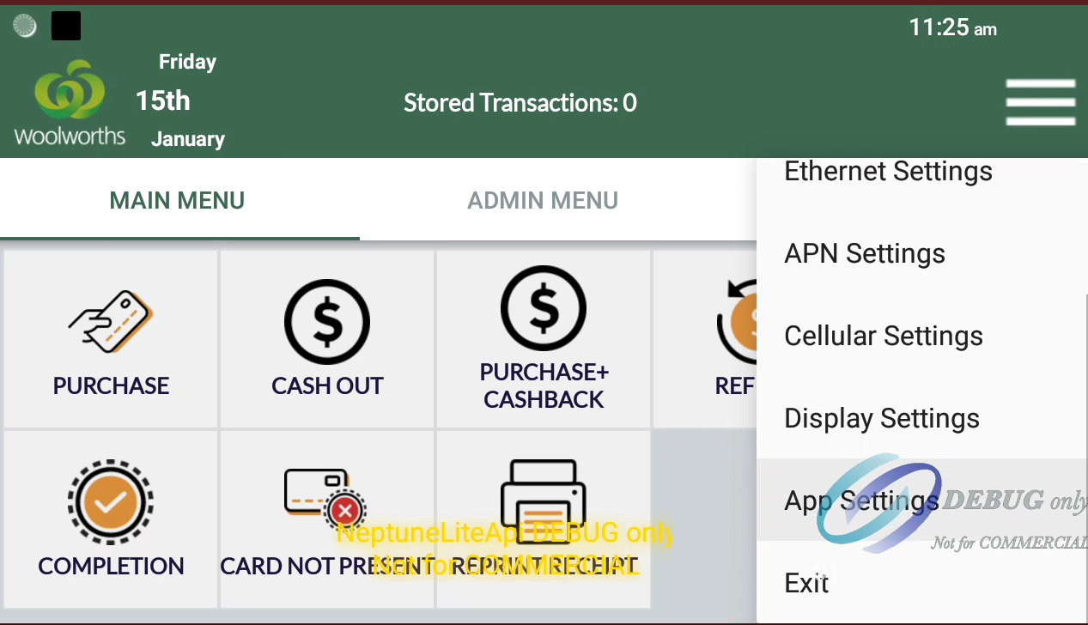

Figure App settings

1. Scroll down to find the USB Settings.  
   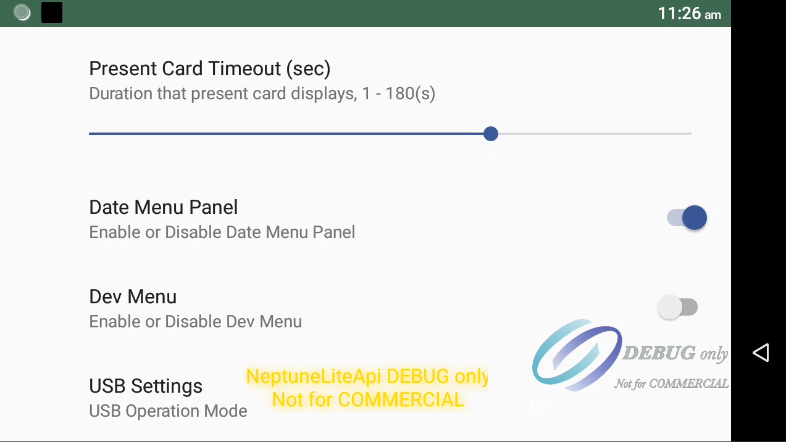

Figure USB Settings

1. Select on the option to open a dropdown menu & scroll down to find USB-PC Internet Share.

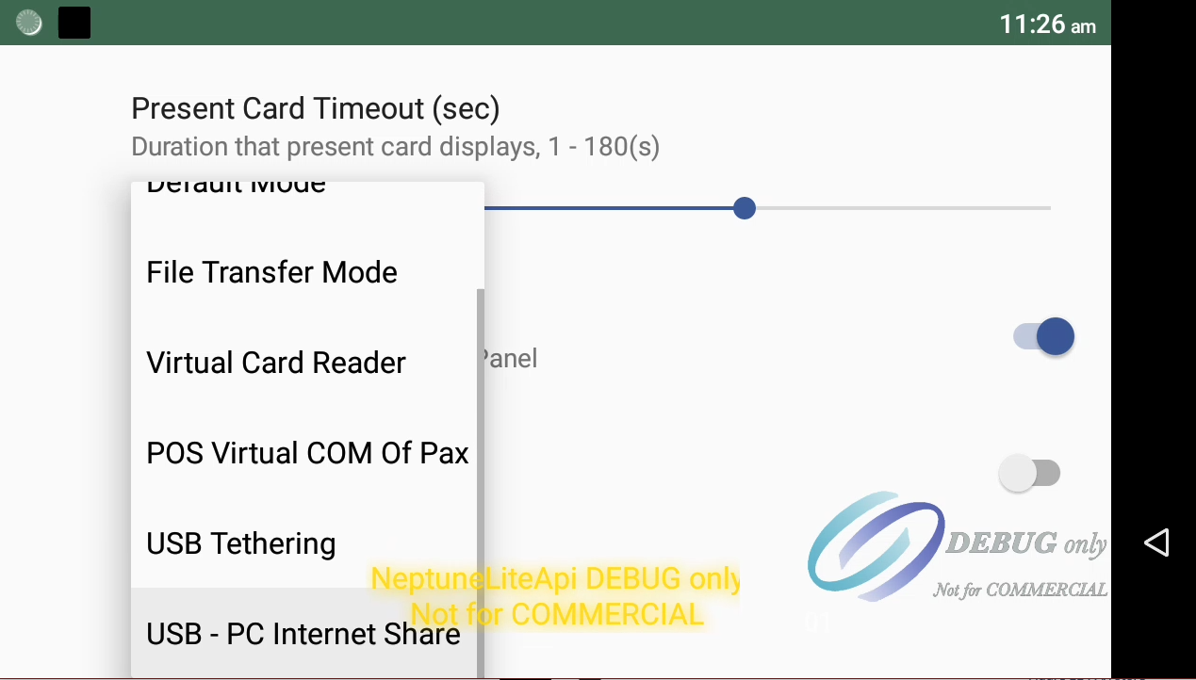

Figure RNDIS Option

1. You should see the adapter as shown in Figure 4 in Network adapters.
2. If RNDIS needs to be disabled, you can click on USB Settings again and select the default mode.

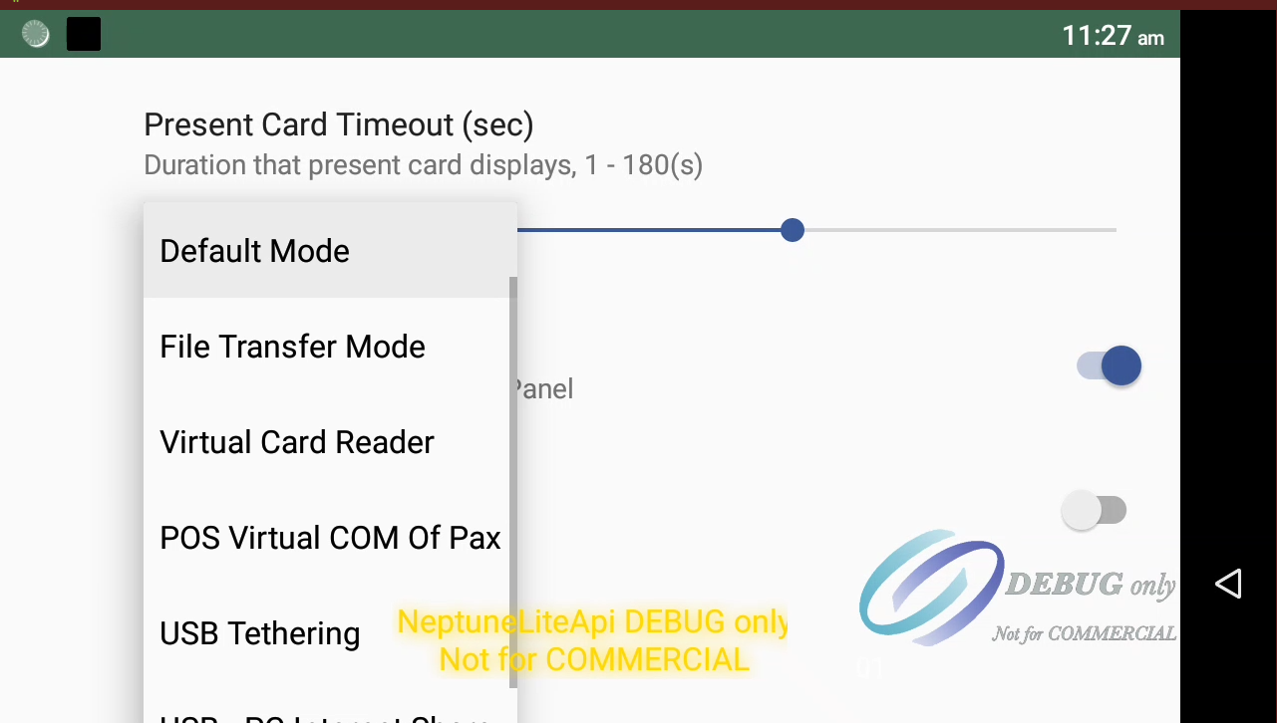

Figure Default USB Mode

### PAX Store web proxy setup

We need a Proxy to listen to the RNDIS Adapter. For the purposes of testing, [Burp Community Suite](https://portswigger.net/burp/communitydownload) was used. Burp Suite allows a proxy to be run on a specific IP Address &/ port.

#### Burp Suite Setup

* Install Burp Community Suite.
* Make sure the A30 is connected via USB Default Mode as we will need to transfer SSL Certificate onto the terminal.
* On Burp Suite, navigate to Proxy Header.   
  

Figure Burp Suite Nav Bar

* We need to install Burp Suite’s SSL Certificate onto the terminal. I don’t think Burp Suite allows non-SSL communication between PC & Terminal.
* I referred to this guide [here](https://portswigger.net/support/installing-burp-suites-ca-certificate-in-an-android-device) to get the SSL Certificate:
  + On Burp Suite, Open Browser which will open a Chromium Browser:  
      
    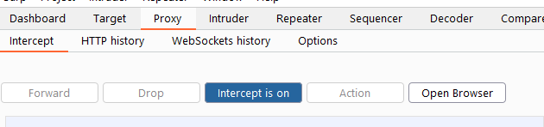

Figure Burp Suite Browser

* + Open <http://burpsuite> **on the opened browser. Click on the CA Certificate on the header and download the .der certificate file.**

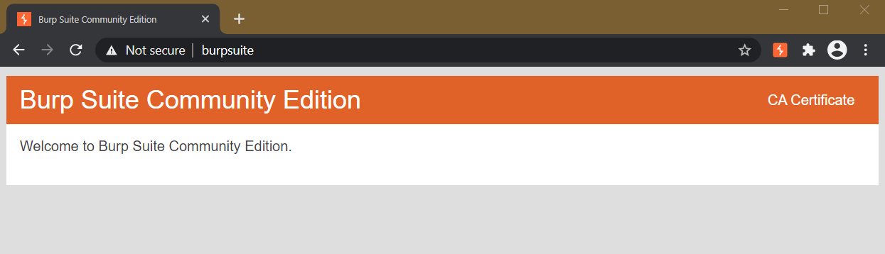

Figure BurpSuite CA Certificate

* + We need to sign the CA Certificate however, only PAX Support can do that right now. I have asked PPN to open CA Certificate signing for us. Once you get the signed CA Certificate from PAX, rename the extension to .cer
  + Download the certificate onto the terminal using ADB: *adb push *.cer /sdcard/Download*
  + On the terminal, navigate to Files -> Download and click on the .cer file. Give it appropriate name and install it.
* Next, the actual Proxy settings on PAX Store Client app:
  + Open PAX Store Client and get to the Proxy settings above the login button.
  + Set the proxy settings as mentioned below. Note: Address of the proxy should be the static IP address of the RNDIS adapter on the PC.

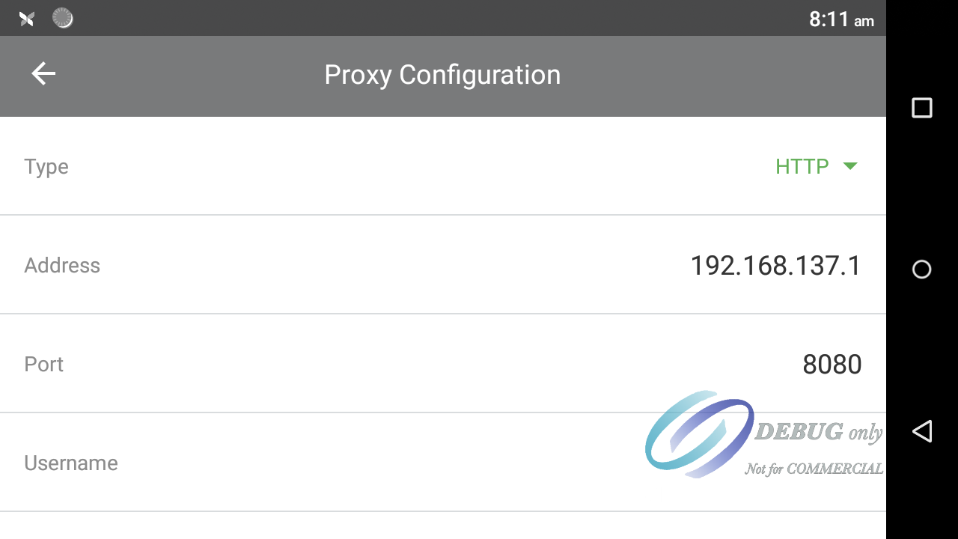

Figure 18 PAX Web Proxy

* Lastly, the Proxy Settings on Burp Suite:
  + Go to Proxy -> Options.
  + Unclick the default proxy running on 127.0.0.1:8080
  + Click Add and setup the proxy as follows

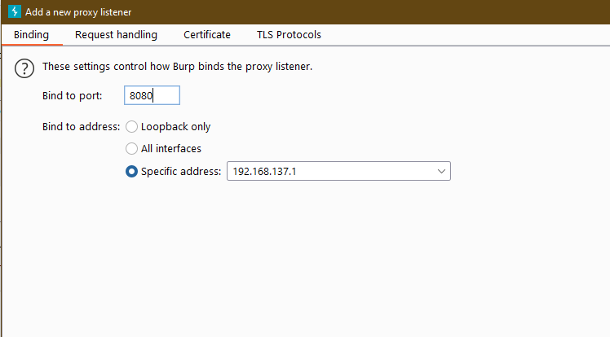

Figure Burp Suite Add a Proxy Listener

* + Click OK & make sure the proxy is running.

#### Running the Proxy

Tu run the proxy, you need to make sure that the Firewall is disabled. I use the following call from Command Line with Admin privileges:

*netsh advfirewall set allprofiles state off*

Make sure that the ‘Intercept’ Button is OFF under Proxy -> Intercept.

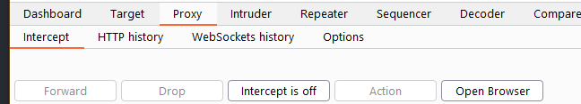

Figure Proxy Intercept

Try connecting the PAX STORE Client app. You should see messages on Burp Suite & PAX STORE Client should activate.

Blockers:

#### Firewall

Windows Firewall blocks any communication from the RNDIS Adapter. Needs more investigation why Firewall does this and how to prevent this from becoming a bigger issue.

As of 21st December, I know it is the firewall as Linkly Connect App can communicate with the EFT Client if I disable the public Firewall.